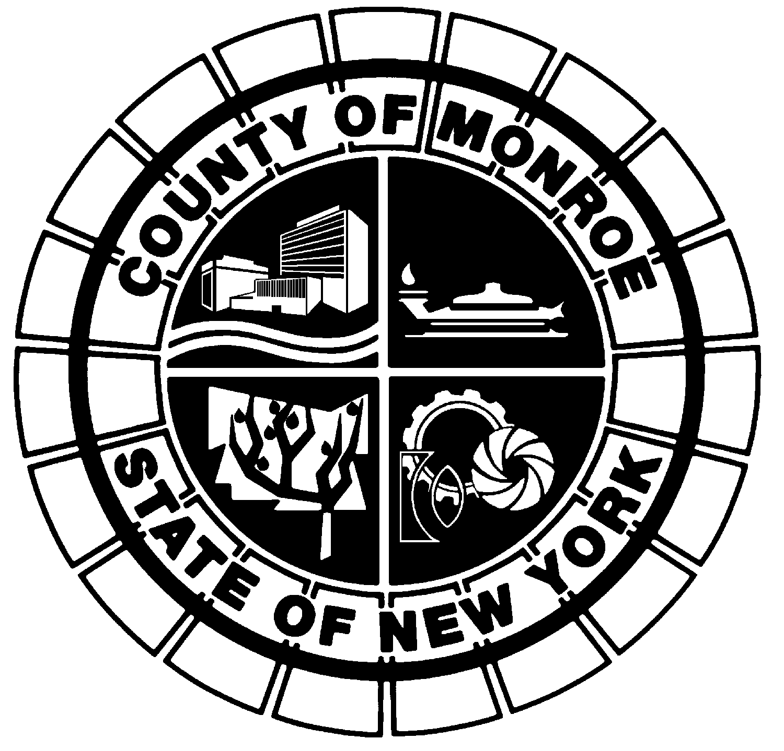
dfgsg
CLIMATE ACTION PLAN
ADVISORY COMMITTEE

Co-Chairpersons
Matthew O’Connor
Michael Yudelson

Vice-Chairperson
Sue Hughes-Smith

Thursday, February 3, 2022
MEMBERS

Appointees

County Executive
Kathryn McArdle

President, Legislature
John Botelho

Legislature Majority
Matthew O’Connor
Co-Chairperson

Legislature Minority
Michael Yudelson
Co-Chairperson
Sue Hughes-Smith
Vice Chairperson

Monroe County DES
Michael Garland

Legislative Majority –
Student
Leah Wirley

Legislative Minority
Student
Helen Frank

County Executive –
Student

3:30 – 5:00 PM
via zoom

Welcome, Introductions & Announcements 5 mins.
Chairpersons O’Connor and Yudelson

Approval of January 6, 2022 Climate Action Committee Minutes 5 mins. Chairpersons O’Connor and Yudelson

Monroe County Legislative Updates
Legislator Yudelson 10 mins.

Ithaca Re-Use Center Tour Report 10 mins.
Attendees

Monroe County Climate Action Plan Update
Joe VanKerkhove / Bergmann Associates / Michael Baker 45 mins.

Public Forum (Registration required) 15 mins.
Chairpersons O’Connor and Yudelson

Next Meeting:
Thursday, March 3, 2022
3:30 P.M.
via zoom

